Name:Sujit Vitthal Nangare

Roll No :A47

Class :MSC–II

Web Frameworks

**ASSIGNMENT-1**

**1) Create an HTML form that contains the Student Registration details and write a JavaScript to validate Student’s first and last name as it should not contain other than the alphabet and the age should be between 18 to 50.**

<HTML>

<head>

<title>Student Registration</title>

</head>

<body>

<h3>Fill the Form</h3>

<label>First Name:</label>

<inputtype="text"  id="fn"name="fname"size="25"><br><br>

<label>Last Name:</label>

<inputtype="text"id="ln"name="lname"size="25"><br><br>

<label>Phone No:</label>

<inputtype="text"id="mob"name="pno"size="25"><br><br>

<label>Age:</label>

<inputtype="text"id="ag"name="age"size="10"><br><br>

<label>Roll No:</label>

<inputtype="text"  name="rollno"size="10"><br><br>

<label>College Name:</label>

<inputtype="text"name="college"size="25"><br><br>

<label>Course:</label>

<inputtype="text"name="course"size="25"><br><br>

<label>Email Id:</label>

<inputtype="text"id="el"name="email"size="25"><br><br>

<label>Password:</label>

<inputtype="password"id="p1"name="pass"size="25"><br><br>

<label>Confirm Password:</label>

<inputtype="password"id="p2"name="pass"size="25"><br><br>

<input  type="submit"value="submit"onclick="create_account()"/>

<scripttype="text/javascript">

    functioncreate_account()

    {

        varfn=document.getElementById("fn").value;

        varln=document.getElementById("ln").value;

        varel=document.getElementById("el").value;

        varag=document.getElementById("ag").value;

        varp1=document.getElementById("p1").value;

        varp2=document.getElementById("p2").value;

        varmob=document.getElementById("mob").value;

        varletters=/^[A-Za-z]+$/;

        varemail_val=/^([a-zA-Z0-9_\.\-])+\@(([a-zA-Z0-9\-])+\.)+([a-zA-Z0-9]{2,4})+$/;

        if(fn==''||ln==''||mob==''||el==''||ag==''||p1==''||p2=='')

        {

            alert("Please Enter each Details Correctly");

        }

        elseif(!letters.test(fn))

        {

            alert('Name is incorrect must contain Alphabates only');

        }

        elseif(!letters.test(ln))

        {

            alert('Name is incorrect must contain alphabats only');

        }

        elseif (!email_val.test(el))

        {

            alert('Invalid email format please enter valid email id');

        }

elseif(ag<18 || ag>50)

{

alert("Age should be between 18 to 50");

}

elseif(p1!=p2)

{

alert("Passwords not matching");

}

elseif(document.getElementById("p1").value.length>12)

{

alert("Password maximum length is 12");

}

elseif(document.getElementById("p1").value.length<6)

{

alert("Password minimum length is 6");

}

else{

alert("Your account has been created successfully...");

window.location="success.html";

}

    }

</script>

</body>

</HTML>

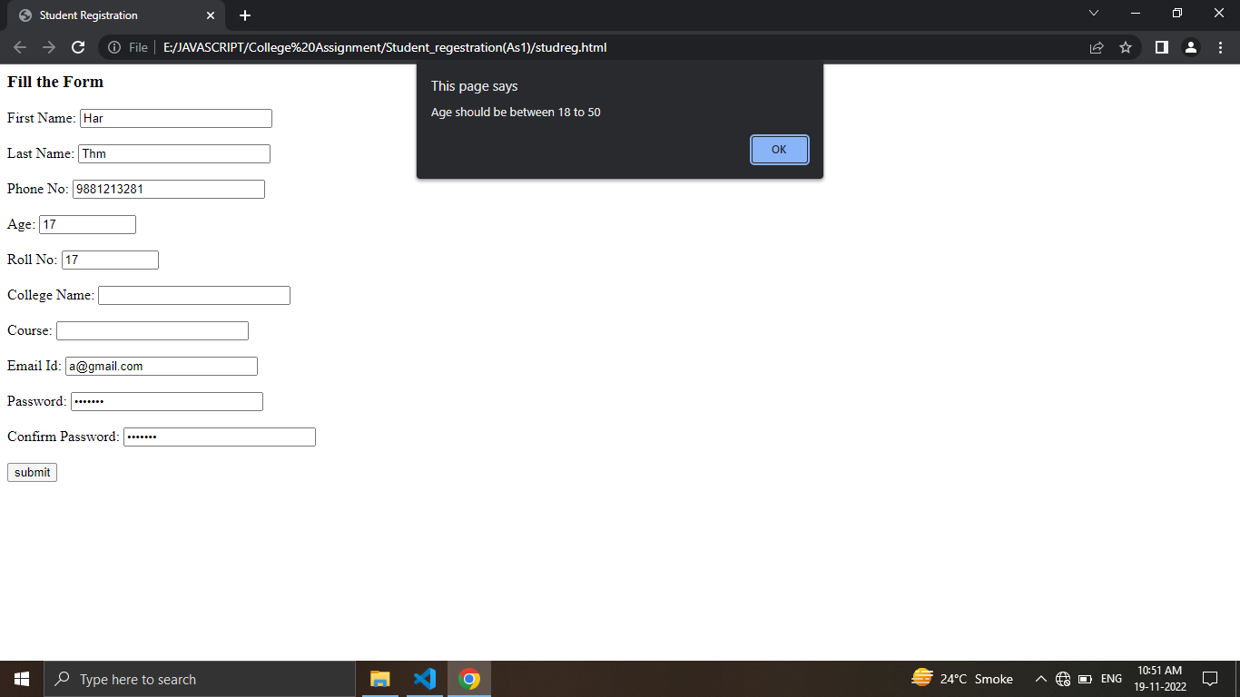

**2) Create an HTML form that contains the Employee Registration details and write a JavaScript to validate DOB, Joining Date, and Salary**.

<!DOCTYPEhtml>

<htmllang="en">

<head>

    <title>Ass2</title>

</head>

<body>

    <divalign="center">

        <h1>Employee Registration</h1>

        <formonsubmit="returnvalidate()"action="success.html">

            <table>

                <tr>

                    <td>First Name</td>

                    <td>

                        <inputtype="text"id="firstname"/>

                    </td>

                </tr>

                <tr>

                    <td>Last Name</td>

                    <td>

                        <inputtype="text"id="lastname"/>

                    </td>

                </tr>

                <tr>

                    <td>Date of Birth</td>

                    <td>

                        <inputtype="date"id="DOB"/>

                    </td>

                </tr>

                <tr>

                    <td>Joining Date</td>

                    <td>

                        <inputtype="date"id="jndate"/>

                    </td>

                </tr>

                <tr>

                    <td>Salary</td>

                    <td>

                        <inputtype="text"id="Salary"/>

                    </td>

                </tr>

            </table>

            <inputtype="submit"value="Submit"/>

        </form>

    </div>

</body>

<script>

    functionvalidate() {

        varfirstname = document.getElementById("firstname").value;

        varlastname = document.getElementById("lastname").value;

        varDOB = newDate(document.getElementById("DOB").value);

        varjndate = newDate(document.getElementById("jndate").value);

        varSalary = document.getElementById("Salary").value;

        vardate_format = /^(0[1-9]|1[0-2])\/(0[1-9]|1\d|2\d|3[01])\/(19|20)\d{2}$/;

        if (firstname == "") {

            alert("First Name is required");

            returnfalse;

        }elseif (lastname == "") {

            alert("Last Name is required");

            returnfalse;

        }elseif (DOB == "") {

            alert("Date of Birth is required");

            returnfalse;

        }elseif (jndate == "") {

            alert("Joining Date is required");

            returnfalse;

        }elseif(jndate.getTime() <DOB.getTime()) {

            alert("Joining Date should be greater than Date of Birth");

            returnfalse;

        }elseif(Salary == "") {

            alert("Salary is required");

            returnfalse;

        }else{

            returntrue;

        }

    }

</script>

</html>

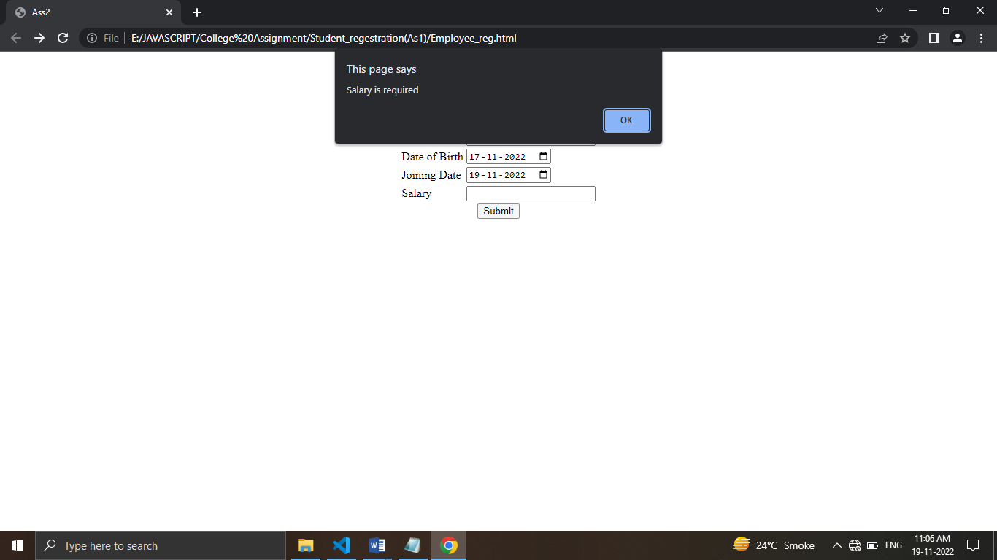

**3) Create an HTML form for Login and write a JavaScript to validate the email ID using Regular Expression.**

<!DOCTYPEhtml>

<htmllang="en">

<head>

    <metacharset="utf-8"/>

    <metaname="viewport"content="width=device-width, initial-scale=1.0"/>

    <title>Login Page</title>

    <linkrel="stylesheet"href="Stylesheet.css"/>

</head>

<body>

    <formaction=""class="form">

        <h1>LOGIN</h1>

        <inputtype="email"  id="el"name="email"class="box"placeholder="Enter Username"/>

        <inputtype="password"name="password"class="box"placeholder="Enter password"/>

        <inputtype="submit"value="LOGIN"id="submit"onclick="account()"/>

    </form>

<scripttype="text/javascript">

    functionaccount()

    {

        varel=document.getElementById("el").value;

        varemail_val=/^([a-zA-Z0-9_\.\-])+\@(([a-zA-Z0-9\-])+\.)+([a-zA-Z0-9]{2,4})+$/;

        if (!email_val.test(el))

        {

            alert('Invalid email format please enter valid email id');

        }

    }

    </script>

</body>

</html>

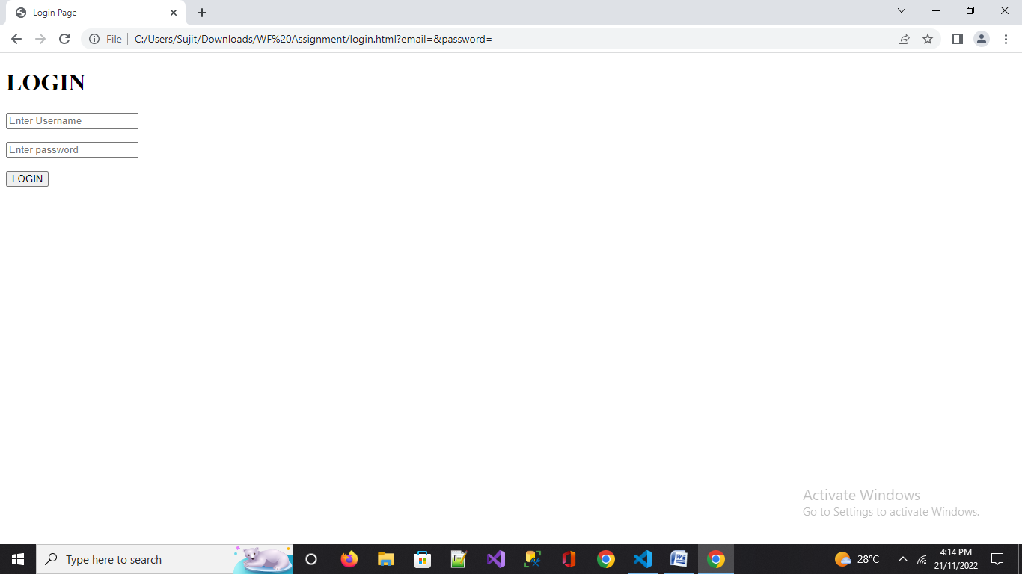

**4) Create a Node.js file that will print the output "Hello World!" on the console**

console.log("Hello World");

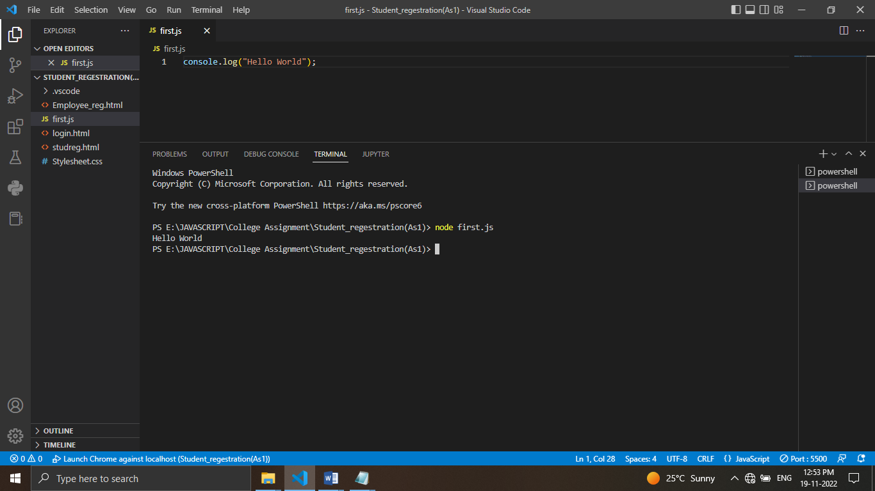

**5) Create a Simple Web Server using node js.**

varhttp = require('http');

http.createServer(function (req, res) {

  // add a HTTP header:

  res.writeHead(200, {'Content-Type':'text/html'});

  res.write('Hello World!');

  res.end();

}).listen(8080);

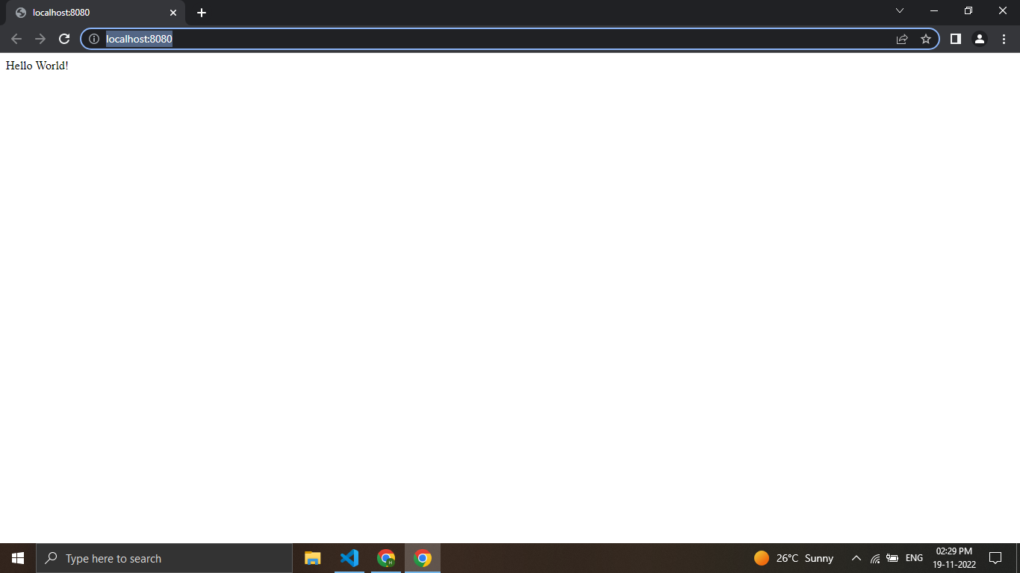

**6)Create a Node.js file that will convert the output "Hello World!" into upper-case letters.**

varhttp=require('http');

varuc=require('upper-case');

http.createServer(function(req,res){

    res.writeHead(200,{'content-Type':'text/html'});

    res.write(uc.upperCase("Hello World!!!"));

    res.end();

}).listen(8081);

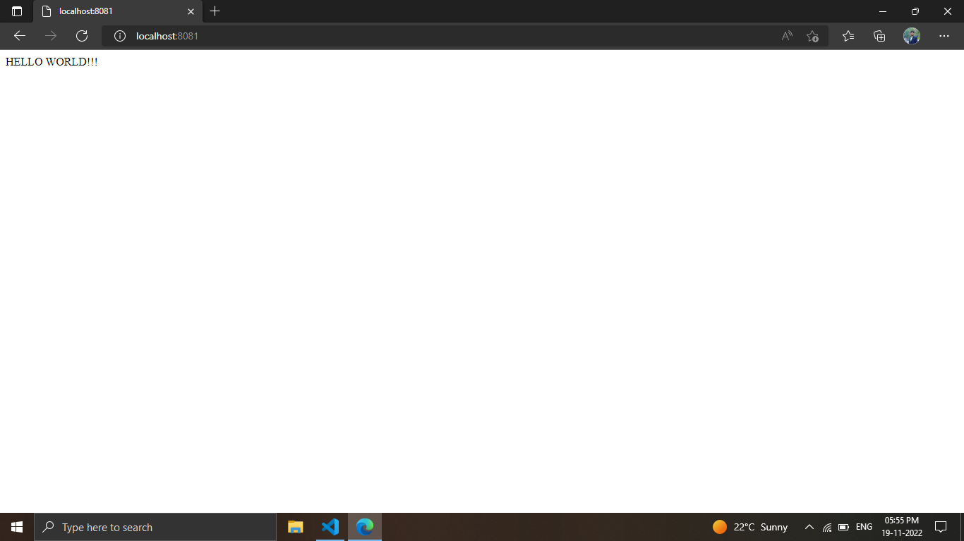

**7) Using nodejs create a web page to read two file names from the user and append the contents of the first file into the second file**

varfs=require('fs');

fs.readFile('first.txt',function(err,data){

    fs.appendFile('second.txt',data,function(err){

        if(err) throwerr;

        console.log('Saved!');

    });

});

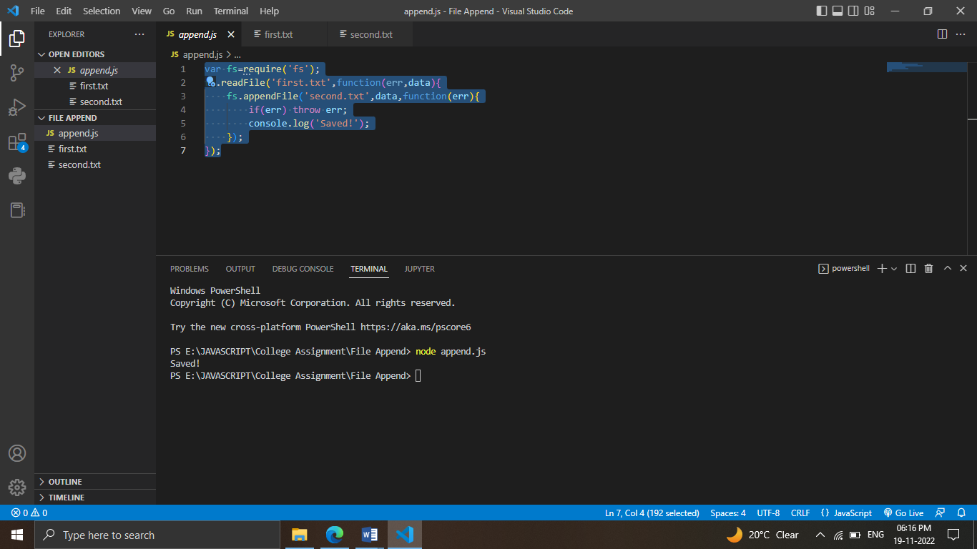

**8) Create a Node.js file that opens the requested file and returns the content to the client. If anything goes wrong, throw a 404 error.**

varhttp=require('http');

varfs=require('fs');

http.createServer(function(req,res){

    fs.readFile('input.txt',function(err,data){

        if(err){

            res.writeHead(404,{'content-Type':'text/html'});

            returnres.end("404 Not Found");

        }

        res.writeHead(200,{'content-Type':'text/html'});

        res.write(data);

        returnres.end();

    });

}).listen(8080);

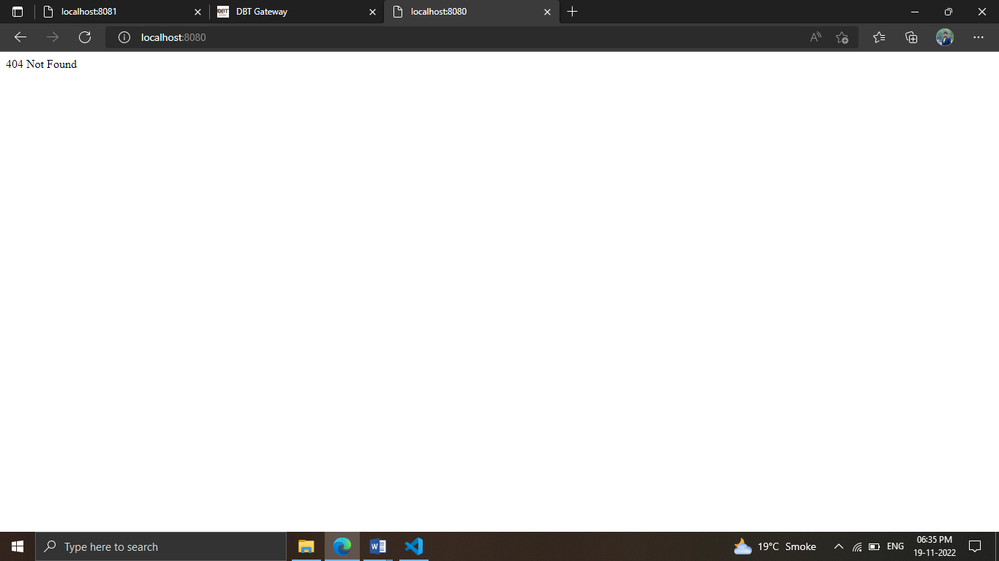

**9)Write node js script to build Your Own Node.js Module. Use require (‘http’) module is a built-in Node module that invokes the functionality of the HTTP library to create a local server. Also use the export statement to make functions in your module available externally. Create a new text file to contain the functions in your module called, “modules.js” and add this function to return today’s date and time**

**Ans:**

**build_node.js**

exports.myDateTime=function()

{

    returnDate();

};

**Demo_build.js**

varhttp=require('http');

vardt=require('./build_node');

http.createServer(function(req,res){

    res.writeHead(200,{'content-Type':'text/html'});

    res.write("The date and time are curentelly:"+dt.myDateTime());

    res.end();

}).listen(8001);

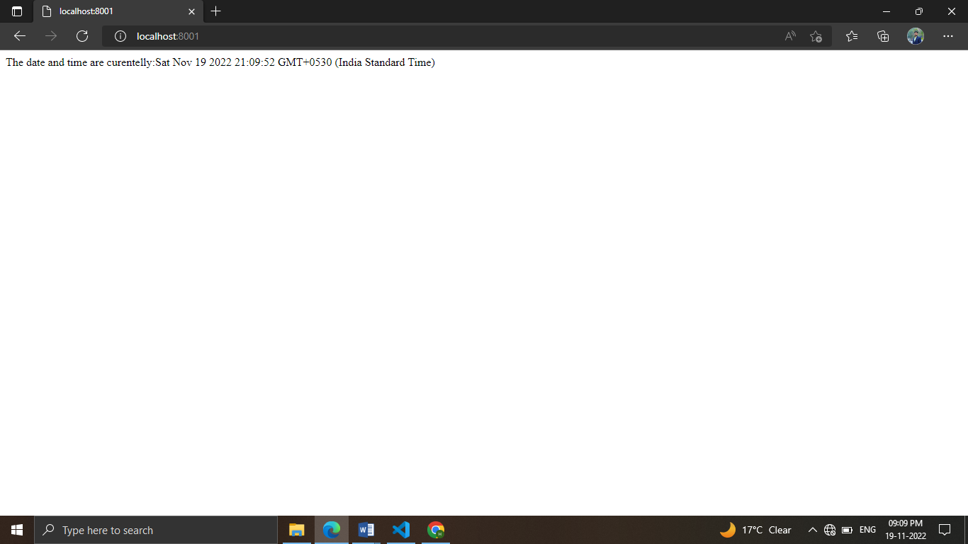

**10**)**Create a js file named main.js for event-driven application. There should be a main loop that listens for events, and then triggers a callback function when one of those events is detected.**

varevents=require('events');

vareventEmitter=newevents.EventEmitter();

varconnectHandler=functionconnected(){console.log('connection Sucessfull.');

eventEmitter.emit('data received');}

eventEmitter.on('connection',connectHandler);

eventEmitter.on('data received',function(){

    console.log('data received succesfully.');

});

eventEmitter.emit('connection');

console.log("programe Ended");

